this is a keyword in Java. It can be used inside the method or constructor of a class. It(this) works as a reference to the current object, whose method or constructor is being invoked.
This keyword can be used to refer to any member of the current object from within an instance method or a constructor.
This keyword refers to the current class instance variable also.

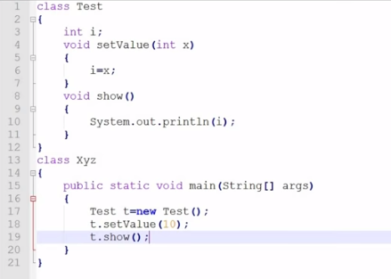

Output 10
Case 1 :
class Test
{
int i;
void setValue(int i)
{
this.i=i;
}
void show()
{
System.out.println(i);
}
}
class XYZ
{
public static void main(String args[])
{
Test t=new Test();
t.setValue(10);
t.show();
}
}
output : 10

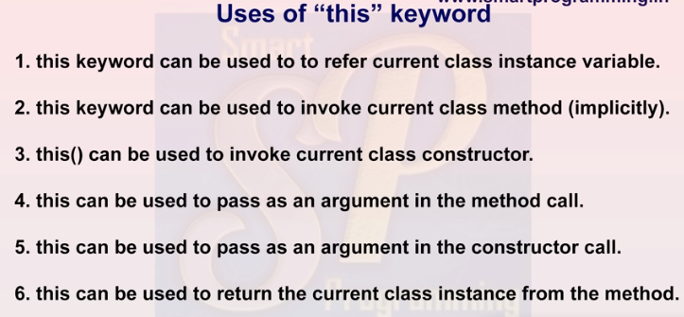

Case 2

public class MyFirstClass {

void show()
{
this.disp();
//disp() or this.disp() by default this keyword is used to invoke method
}

void disp()
{
System.out.println("hello");

}

public static void main(String args[])
{
MyFirstClass s1 = new MyFirstClass();

s1.show();
} }

case 3

public class MyFirstClass {

MyFirstClass(){

System.out.println("No arg constructor");
}
MyFirstClass(int n){
System.out.println("one arg constructor");

}

public static void main(String args[])
{
MyFirstClass s1 = new MyFirstClass(); //output No arg constructor
}
}

MyFirstClass(){

System.out.println("No arg constructor");
}
MyFirstClass(int n){
System.out.println("one arg constructor");

}

public static void main(String args[])
{
MyFirstClass s1 = new MyFirstClass(10); //output one arg constructor

}
}
3. if we want to invoke parameterized but also default then use this() keyword.
public class MyFirstClass {

MyFirstClass(){

System.out.println("No arg constructor");
}
MyFirstClass(int n){
this();
System.out.println("one arg constructor");

}

public static void main(String args[])
{
MyFirstClass s1 = new MyFirstClass(10);
}
}

4. if we want to invoke parameterized but via default then use this(10) keyword.
public class MyFirstClass {

MyFirstClass(){
this(10);

System.out.println("No arg constructor");
}
MyFirstClass(int n){
System.out.println("one arg constructor");

}

public static void main(String args[])
{
MyFirstClass s1 = new MyFirstClass();
}
}

//output
one arg constructor
No arg constructor

case 4

public class MyFirstClass {

void m1(MyFirstClass f1)
{
System.out.println(" in m1");
}
void m2()
{
m1(this);
}
public static void main(String args[])
{
MyFirstClass s1 = new MyFirstClass();
s1.m2();
}}

case 6

public class MyFirstClass {
MyFirstClass m1()
{
System.out.println("HELLO");
return this;
}
public static void main(String args[])
{
MyFirstClass s1 = new MyFirstClass();
s1.m1();
} }

Case 5
public class ADD{

void m1()
{
Example t= new Example(this);
} public static void main(String args[]) {

ADD s1 = new ADD();
s1.m1(); }}
public class Example {
Example(ADD td)
{
System.out.println(" in class constructor");}}

